WHEN a webpage is loaded a file is made called dom made by browser.

To make interaction between files and functions together.

A document tree is made.

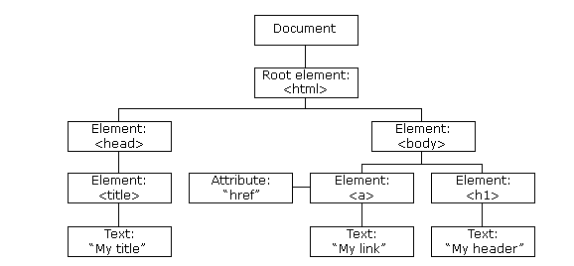

Dom adds events to your html page by using javascript methods.

This functions brings dynamic changes to your webpage like :

Onclick , onmouseover , eventlistner , buttons , bullets , dropdowns selections etc.

